Department of Computer Applications

II MCA Java Lab – HS12 on IO Stream

You will write a program to compute a car’s gas mileage and the amount you spend per mile traveled. In particular, ask the user for the following.

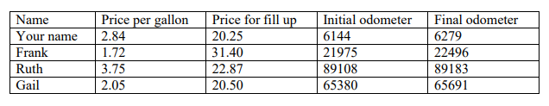

Write this information into a file. And read the content, compute the total miles drive, the number of gallons of gas used (total amount for fill-up / price per gallon), and the miles per gallon that the car achieved (total miles / number of gallons). Note that number of gallons and miles per gallon will both be doubles. Display the results properly.

